Revision History
Date | Version | Description | Author
25/10/2025 | 1.1 | Document overview and System Overview parts were added. | Murad Seyfullayev
26/10/2025 | 1.2 | User requirements and system  requirements were specified. | Özgür Yılmaz, Alp Eren Erdur, Tuna Özen
27/10/2025 | 1.3 | Package Diagram was added. | Özgür Yılmaz
27/10/2025 | 1.4 | Activity Diagram was added. | Murat Tuna Özen, Alp Eren Erdur
27/10/2025 | 1.5 | Use Case diagram was added. | Alp Eren Erdur, Tuna Özen
01/11/2025 | 1.6 | Use Case and Activity Diagram issues were fixed and added a new Activity Diagram. | Murat Tuna Özen, Özgür Yılmaz, Murad Seyfullayev, Alp Eren Erdur
01/11/2025 | 1.7 | Issues in the Overview, User and System Requirements parts were addressed and finalized. | Alp Eren Erdur

TABLE OF CONTENTS
Revision History 1
1 INTRODUCTION 3
1.1 Document overview 3
1.2 System overview 3
1.3 Abbreviations 3
1.4 References 3
1.5 Conventions 3
2 REQUIREMENTS 4
2.1 User Requirements Specification 4
2.2 System Architecture 5
2.3 Use Cases and Usage Scenarios 6
2.4 System Requirements Specification 8

INTRODUCTION

Document overview

This document presents the software requirements specifications of HMS software development project. It describes functional requirements, quality requirements, constraints, use cases, and usage scenarios. It also provides an overview of the system architecture.

System overview
HMS (Hospital Management System) is a Java desktop application designed to digitalize hospital operations and improve communication between hospital members.
The system supports four main user types: Managers, Doctors, Patients, and Administrators.
Each user type has specific capabilities:
- Administrator: Responsible for managing system-wide configurations, user accounts, and access control.
- Manager: Manages hospital resources such as departments, doctors, and patients within their hospital. They can view reports and monitor appointments.
- Doctor: Can view their scheduled appointments, manage patient medical records, set their availability, and generate medical reports for patients.
- Patient: Can register, log in, book and cancel appointments with available doctors, and view their own medical records and prescriptions (but cannot generate or edit them).

Abbreviations
HMS: Hospital Management System
UML: Unified Modeling Language
IDE: Integrated Development Environment
JDK: Java Development Kit
SRS: Software Requirement Specification
STP: Software Test Plan
SDD: Software Design Document
STR: Software Test Report
JavaFX: Java Effects
SQL: Structured Query Language

References

# | Document Identifier | Document Title
[R1] | SIS-SDP-v2.0 | Software Development Plan of HMS software

Conventions
Requirements listed in this document are constructed according to the following structure:

SRS-HMS-001
Description of HMS-001 requirement

Every system requirement id includes the id of the corresponding user requirement as a prefix.
SRS-HMS-001.1 Description of SRS-HMS-001.1 system requirement, which is related to the user requirement SRS-HMS-001

REQUIREMENTS

User Requirements Specification
SRS-HMS-001
HMS shall enable patients to register, log in, and manage their own profiles (update personal information, change password).

SRS-HMS-002
HMS shall enable patients to create, view, and cancel appointments with available doctors.

SRS-HMS-003
HMS shall enable patients to view their medical records, prescriptions, and doctor notes.

SRS-HMS-004
HMS shall enable patients to rate and review doctors after completed appointments.

SRS-HMS-005
HMS shall enable doctors to set and modify their weekly availability schedule.

SRS-HMS-006
HMS shall enable doctors to view their appointments (scheduled, completed, cancelled).

SRS-HMS-007
HMS shall enable doctors to create, edit, and view medical records for patients they have treated.

SRS-HMS-008
HMS shall enable managers to create, edit, and remove doctor and patient accounts.

SRS-HMS-009
HMS shall enable managers to view hospital-wide appointment and performance data.

SRS-HMS-010
HMS shall enable managers to generate reports containing appointment statistics, doctor workloads, and patient satisfaction ratings.

SRS-HMS-011
HMS shall enable administrators to manage user roles and access permissions across the system and perform full and incremental database backups and restore previous system states in case of data loss or corruption.

SRS-HMS-012
HMS shall notify users (via message popup or email) for key operations such as appointment confirmation, cancellation, and password reset.

SRS-HMS-013
HMS shall enable administrators to perform full and incremental database backups and restore previous system states when required.

System Architecture

Package Diagram

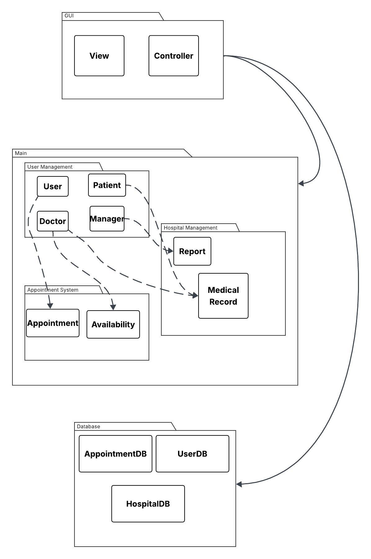

2.3 Use Cases and Usage Scenarios

UML Use Case Diagram
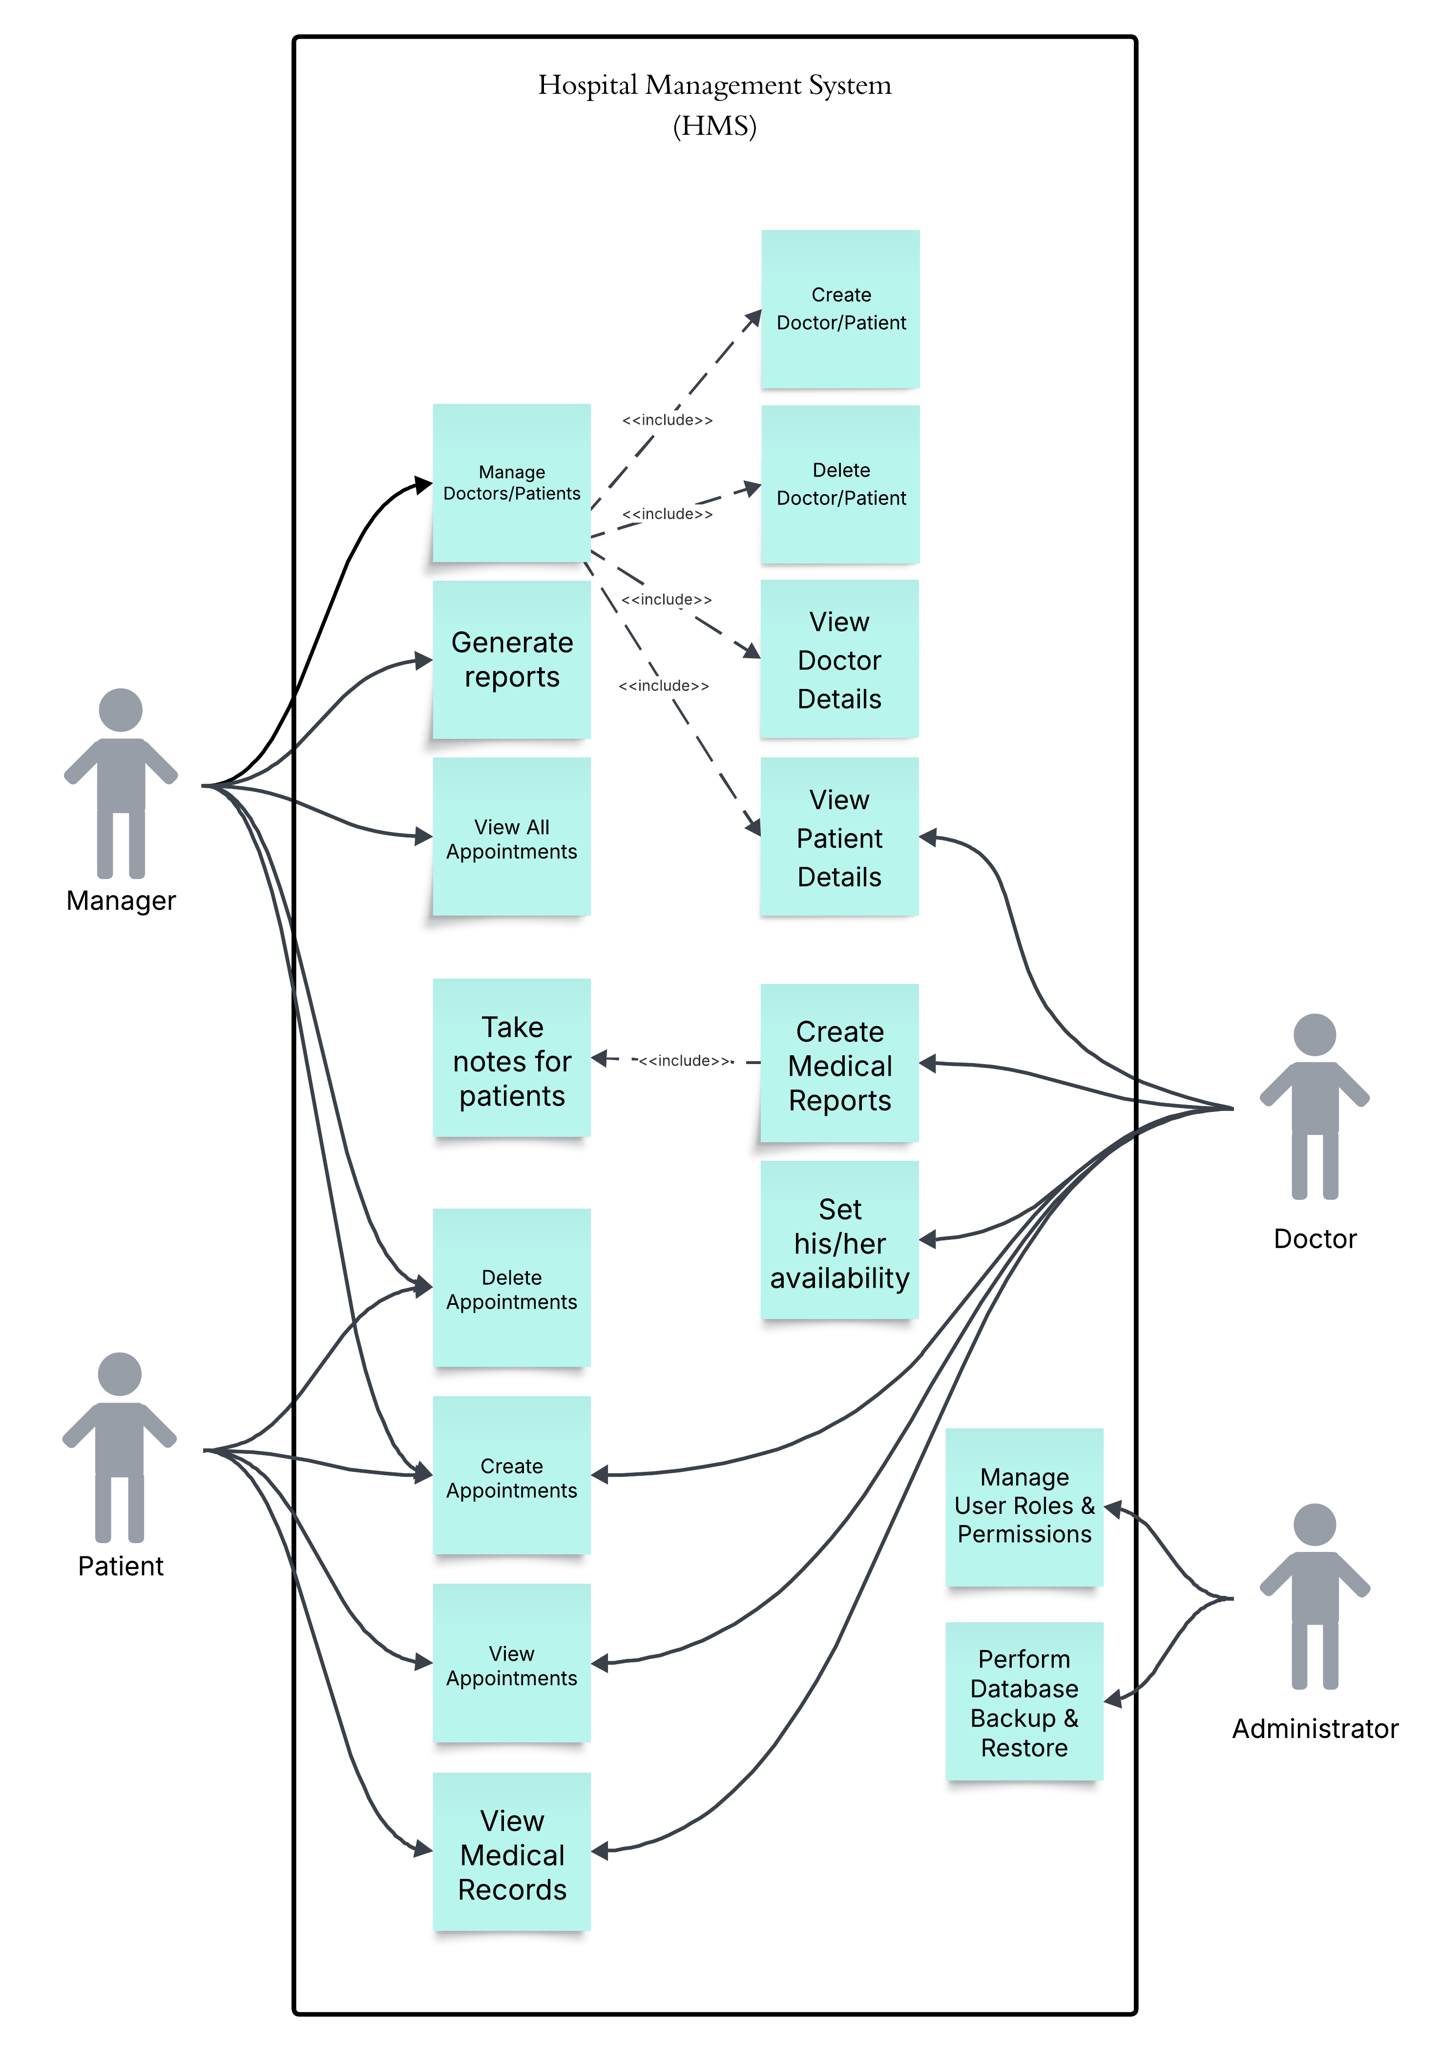

UML Activity Diagram 1

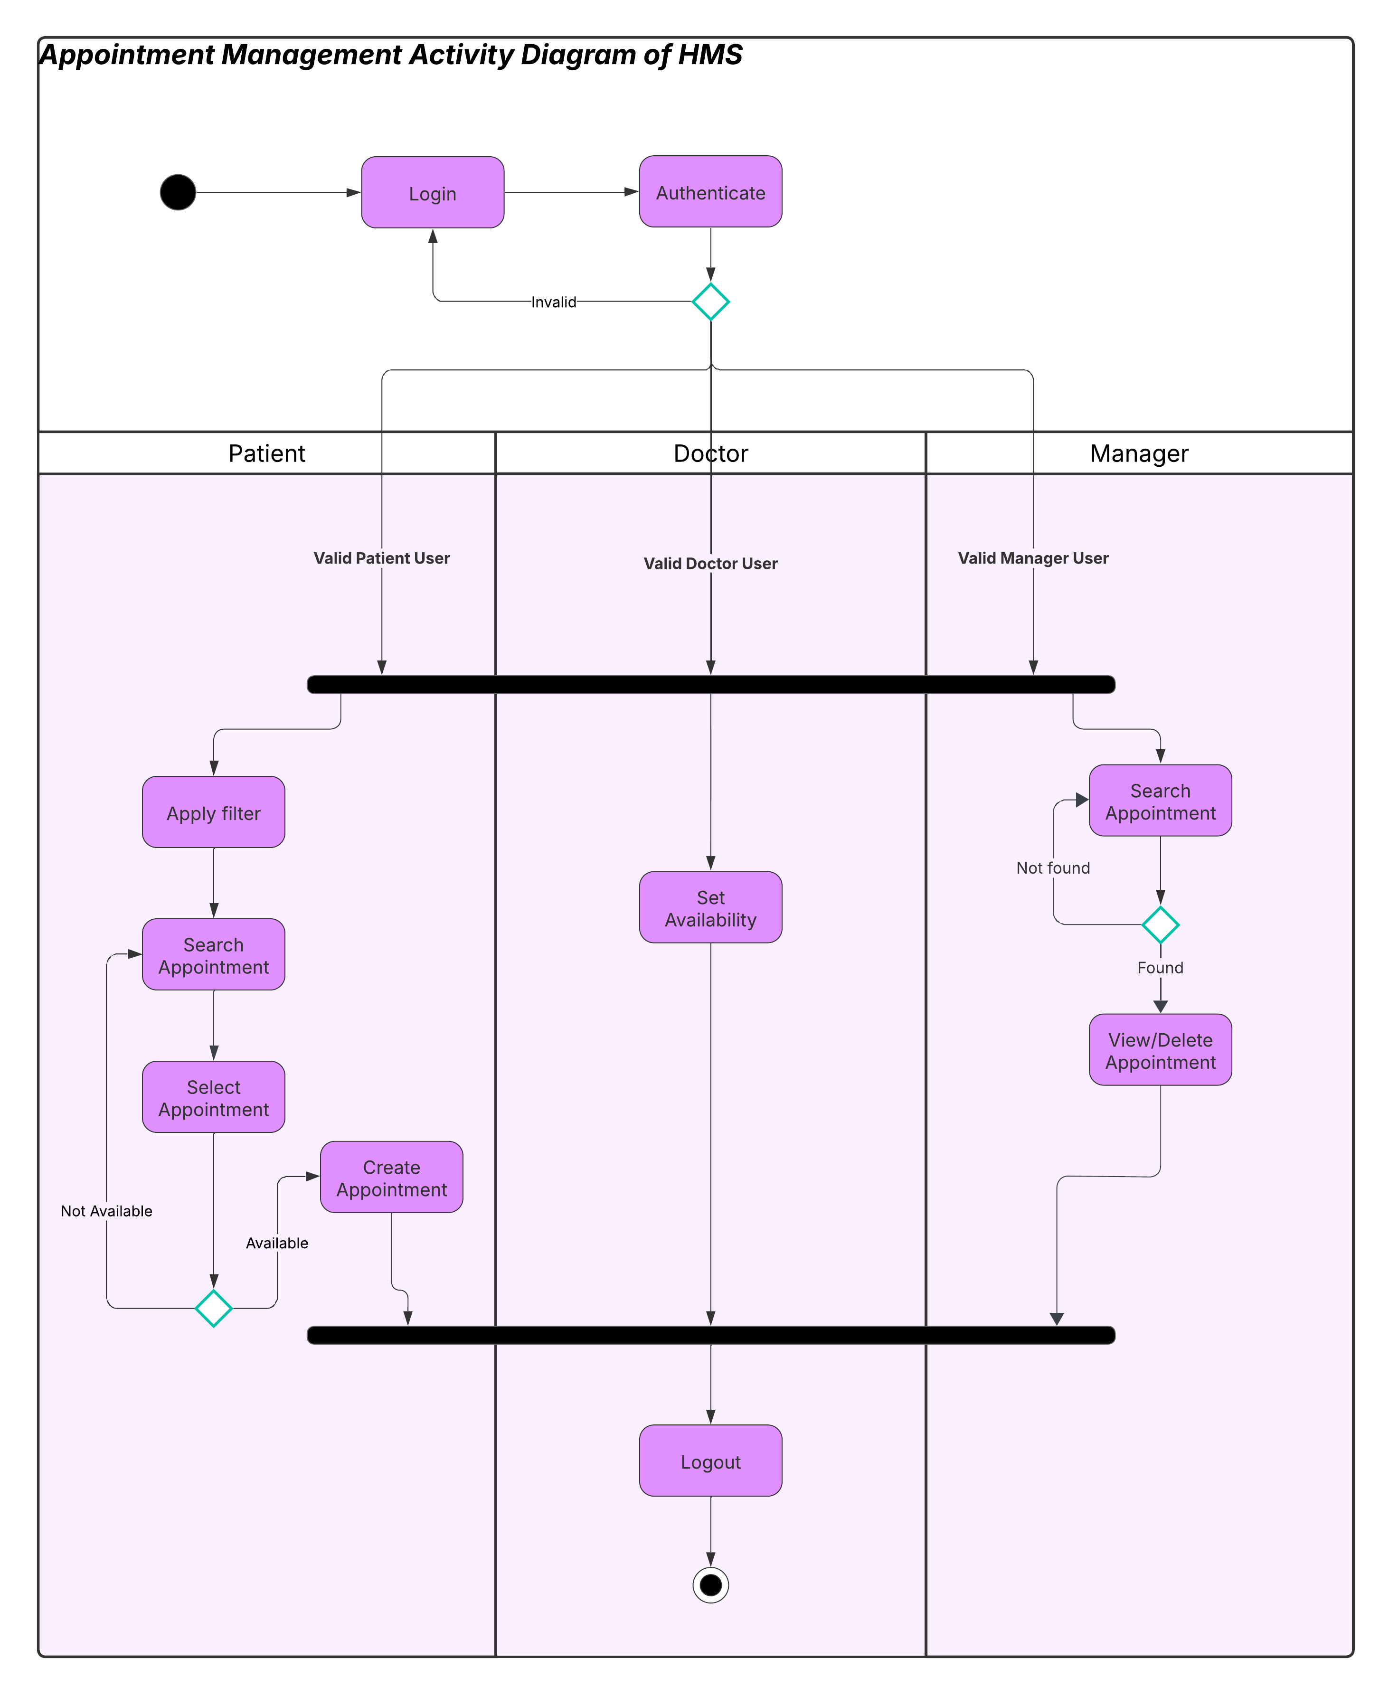

UML Activity Diagram 2

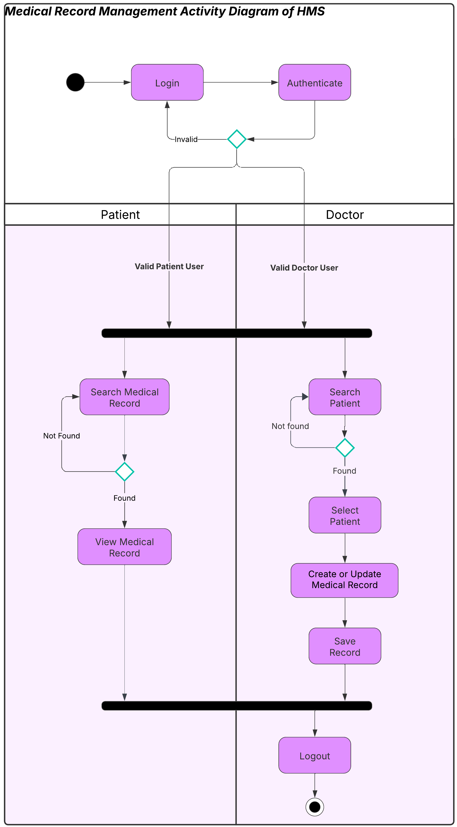

System Requirements Specification

SRS-HMS-001.1
The system shall validate all user input fields during registration, including:
• Email format (e.g., user@example.com)
• Password strength (minimum 8 characters, at least one uppercase letter, one number, and one special character)
• Phone number format (e.g., +90 555 123 4567)
SRS-HMS-001.2
The system shall limit login attempts to five before temporarily locking the account for 10 minutes.
SRS-HMS-001.3
The system shall display appropriate error messages for failed login, registration, or invalid inputs.
SRS-HMS-001.4
The system shall allow users to reset forgotten passwords through a secure password recovery mechanism (e.g., email verification).

SRS-HMS-002.1
The system shall allow patients to create appointments only if the selected doctor has an available slot.
SRS-HMS-002.2
The system shall prevent appointment overlaps for the same doctor and time slot.
SRS-HMS-002.3
The system shall generate a unique appointment ID upon successful booking.
SRS-HMS-002.4
The system shall send confirmation and cancellation notifications to both the doctor and the patient.
SRS-HMS-002.5
The system shall automatically update the appointment status to “completed” once the scheduled time has passed.

SRS-HMS-003.1
The system shall restrict appointment creation to valid hospital branches, doctors, and clinics.
SRS-HMS-003.2
The system shall validate patient insurance number format before confirming the appointment.
SRS-HMS-003.3
The system shall allow filtering appointments by doctor, clinic, or hospital branch in the appointment view interface.
SRS-HMS-003.4
The system shall display error messages if an appointment creation fails due to unavailable time or invalid input.

SRS-HMS-004.1
The system shall allow doctors to view and edit medical records only for patients they have treated.
SRS-HMS-004.2
The system shall store each medical record with:
• Record date
• Diagnosis
• Test results
• Prescribed medications
• Doctor notes
SRS-HMS-004.3
The system shall timestamp all medical record changes and store the ID of the editing doctor.
SRS-HMS-004.4
The system shall prevent deletion of medical records once created, ensuring medical history integrity.

SRS-HMS-005.1
The system shall allow doctors to define their availability by specifying date and time slots.
SRS-HMS-005.2
The system shall prevent doctors from setting availability outside hospital working hours (08:00–18:00, Monday–Friday).
SRS-HMS-005.3
The system shall disable selection of past dates or times when setting availability.
SRS-HMS-005.4
The system shall mark booked slots as unavailable to prevent double-booking.

SRS-HMS-006.1
The system shall restrict access to patient personal and medical information to authorized roles only (doctor, manager, admin).
SRS-HMS-006.2
The system shall encrypt sensitive data such as passwords and medical information in the database.
SRS-HMS-006.3
The system shall log all user activities, including logins, record updates, and account deletions, for auditing purposes.
SRS-HMS-006.4
The system shall display appropriate warning messages when unauthorized access is attempted.

SRS-HMS-007.1
The system shall allow managers to generate hospital performance reports including:
• Number of appointments per doctor
• Number of cancellations
• Average patient satisfaction rating
• Doctor workloads per clinic
SRS-HMS-007.2
The system shall allow exporting reports as PDF or CSV files.
SRS-HMS-007.3
The system shall restrict report generation to manager and admin roles only.

SRS-HMS-008.1
The system shall perform automatic daily database backups at midnight.
SRS-HMS-008.2
The system shall allow administrators to manually trigger data backup and recovery.
SRS-HMS-008.3
The system shall restore the last successful backup in case of data loss or system crash.

SRS-HMS-009.1
The system shall display a confirmation message after every successful operation (e.g., appointment creation, record update).
SRS-HMS-009.2
If an operation fails due to invalid input or server issues, the system shall display an error message indicating the problem.
SRS-HMS-009.3
The system shall ensure that response time for user operations (e.g., booking, record retrieval) does not exceed 3 seconds.

